Script 2:

1. Get a list of all instances.

2. Stop all running instances at specified times, for example:

- Start instances at 10 AM.

- Stop instances at 7 PM.

**1. Created two instances**

**Instance-1**

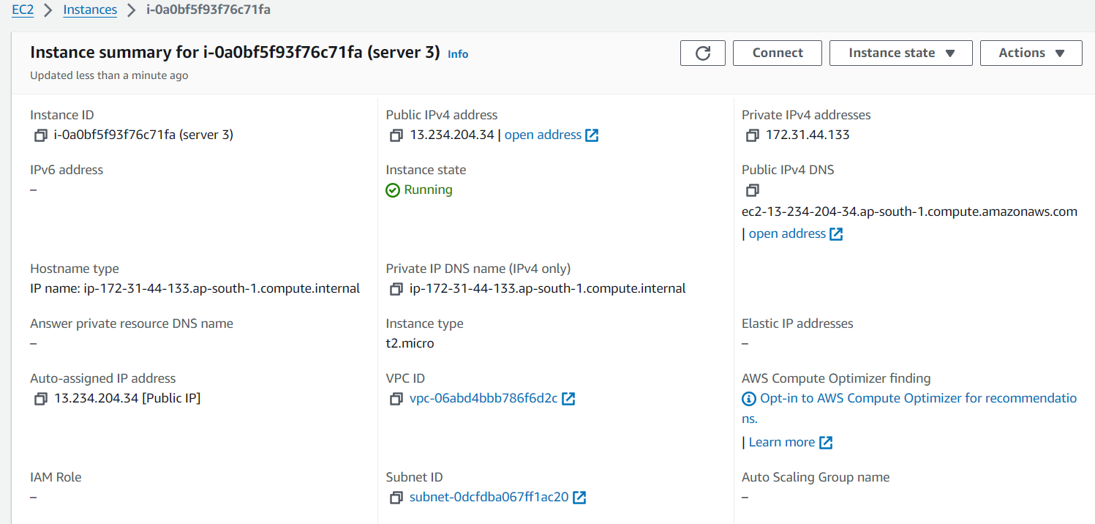

**Instance-2**

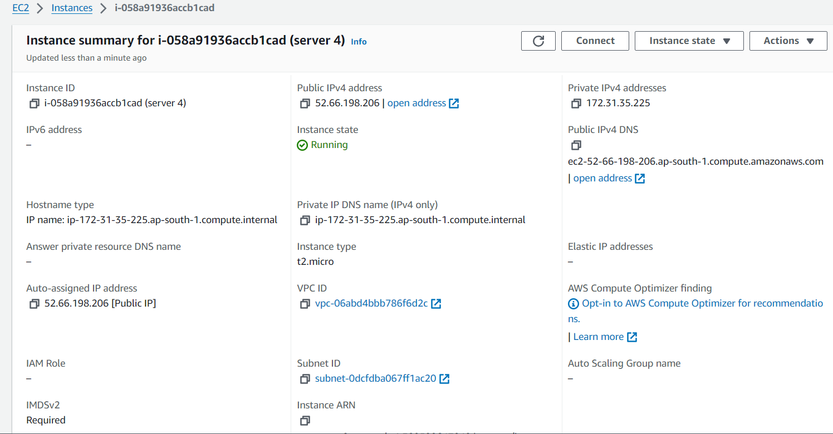

**Created SNS Topic**

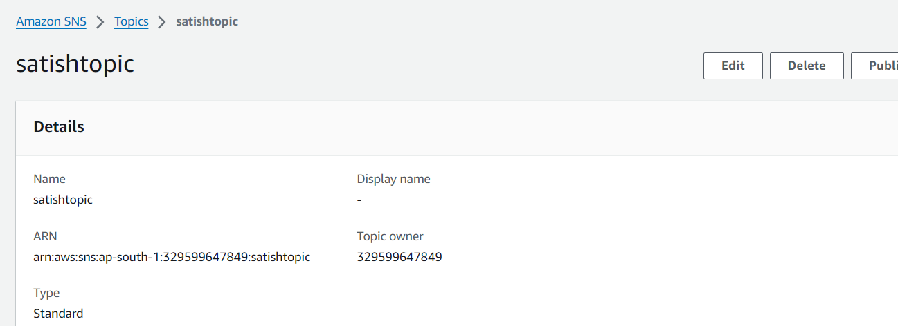

**Created a policy in the IAM User**

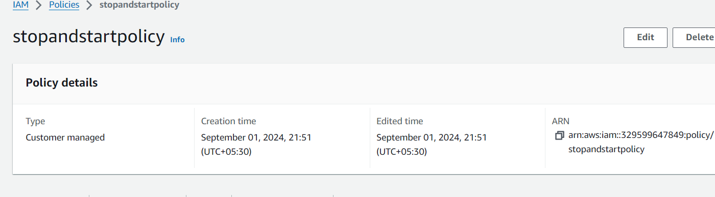

**Created a role in the IAM user and attached policy to it.**

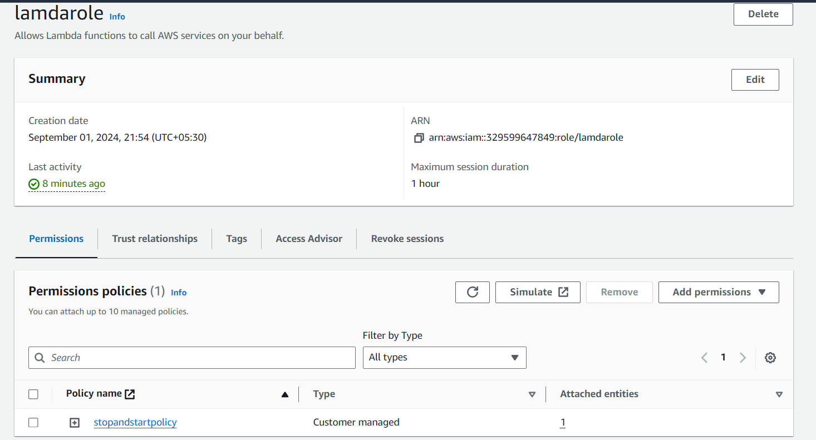

**Create a stop function in the Lamda and deploy code in the stop function**

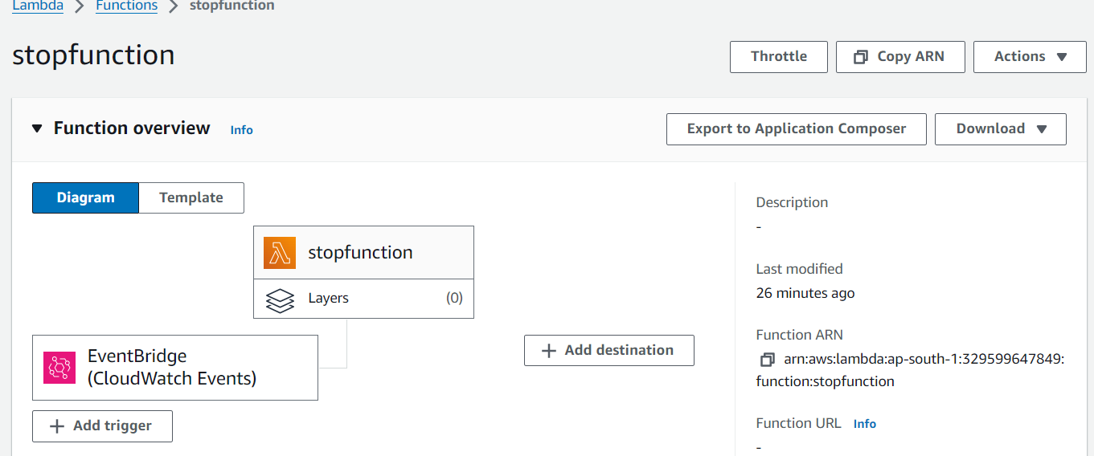

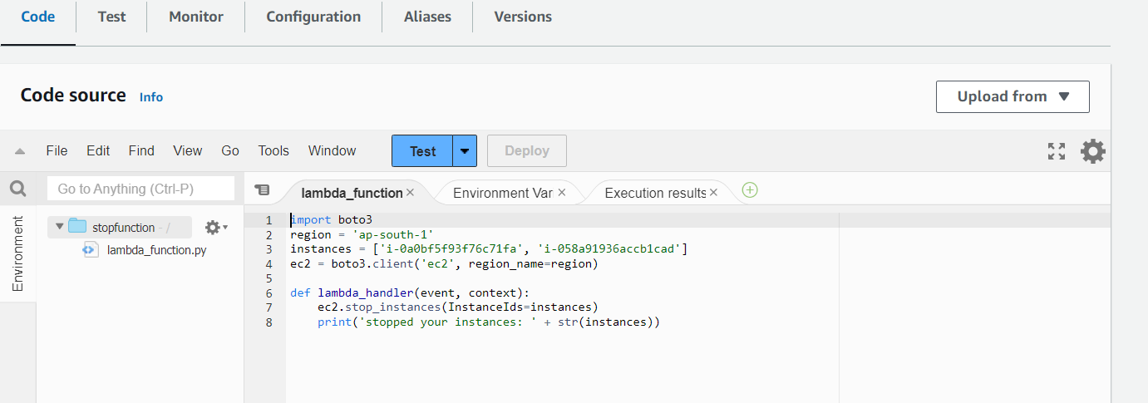

**Create a stop rule in cloudwatch and schedule to stop the instance using cron expression**

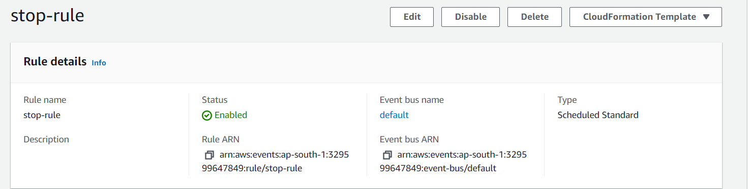

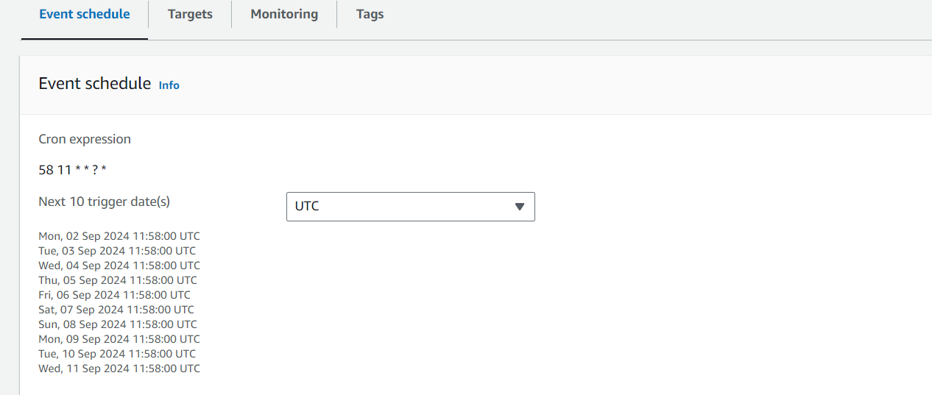

**Instance was stopped using the cron expression at scheduled time**

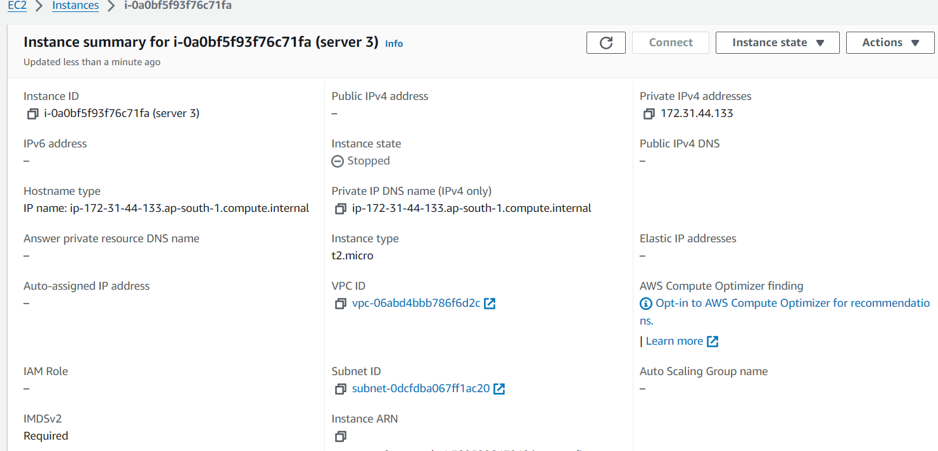

**Create a start function in the lambda and deploy the code in the start fun**

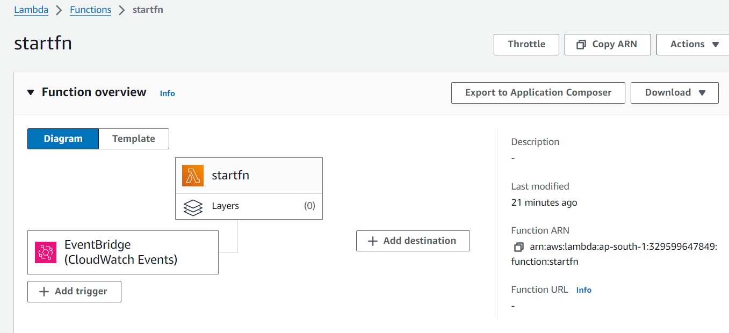

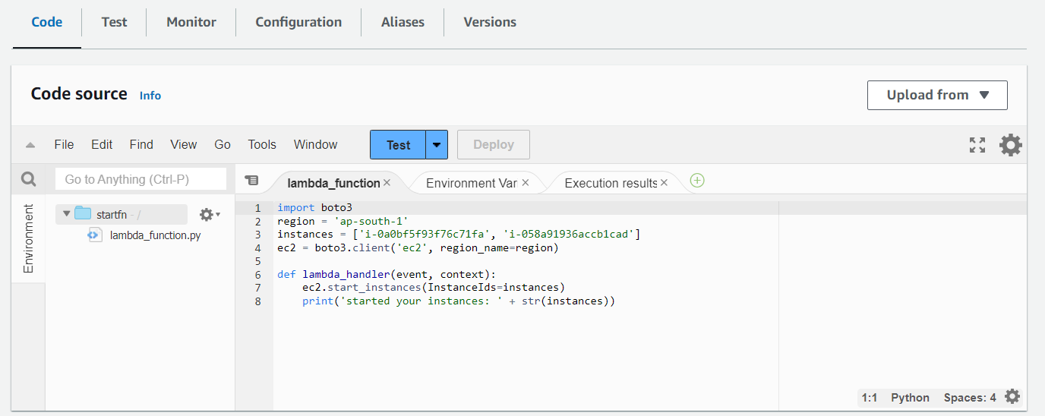

**Create a start rule in cloudwatch and schedule to start the instance using cron expression**

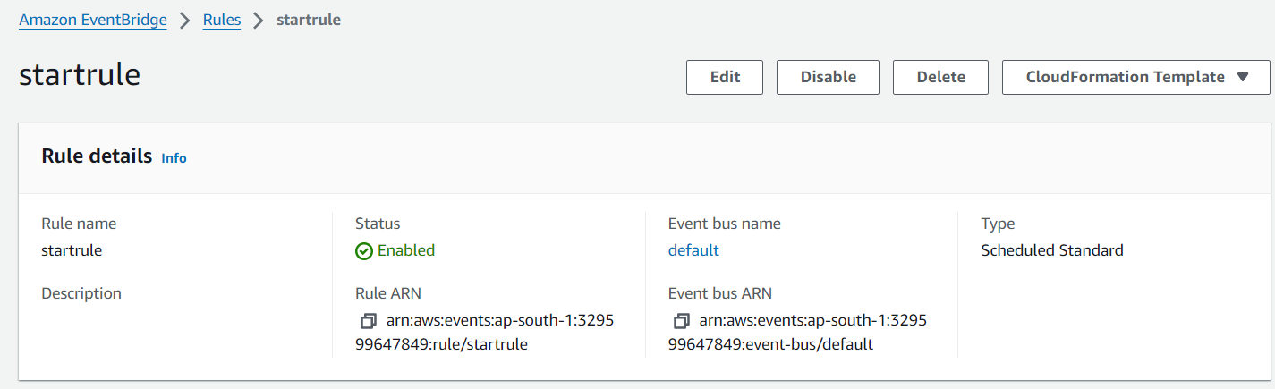

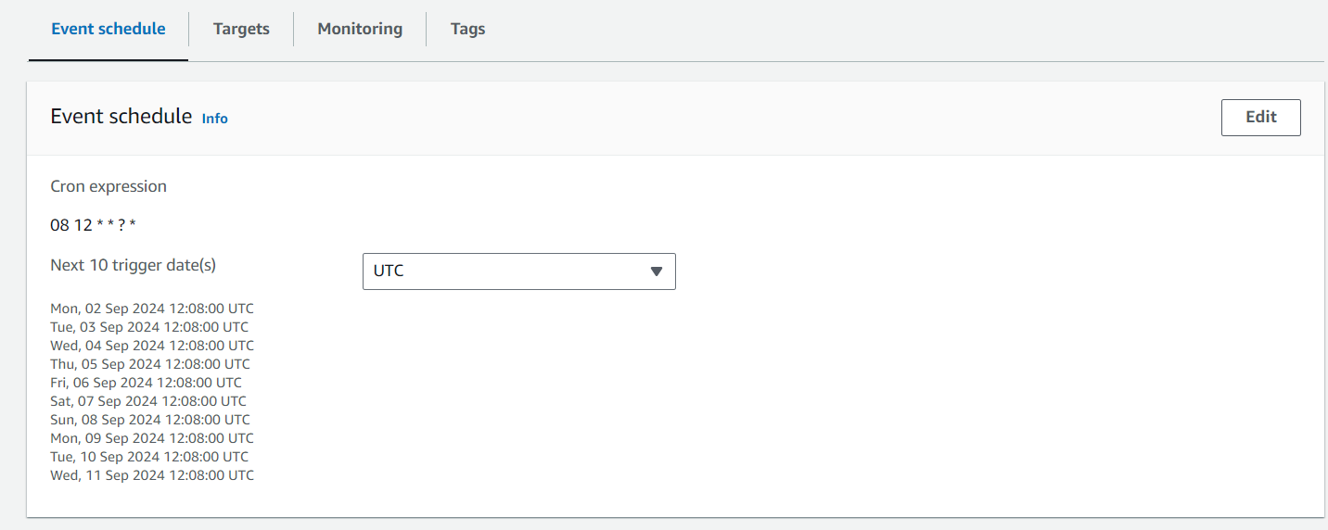

**Instance was started using the cron expression at scheduled time**

